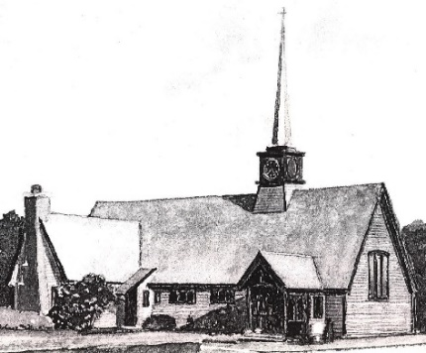

Holy Eucharist

Third Sunday of easter

april 14, 2024, 9:00am

Christ Church Episcopal
671 Route 28, Harwich Port, MA 02646 508-432-1787
www.christepiscopalharwich.org christchurchharwichport@comcast.net
The Rev. Donna Foughty, Rector

Maggie Ribb, Minister of Music
Todd Woolley, Sexton
Lisa Berman, Parish Administrator

Vestry
Bill Walsman, Todd Woolley, Wardens
Karen Butler, Treasurer; Lisa Delong, Assistant Treasurer; Bob Lawton, Clerk
James Creutz, Jennifer Lutz, and Elaine Mason, Members

Sharing Christ’s love in the world and creating a nurturing place for all.
Prelude Blessed Jesus, At Thy Word J.S. Bach

Processional Sing, Ye Faithful, Sing With Gladness #492 Hymnal 1982

The people standing, the Celebrant says

Celebrant Alleluia. Christ is risen.
People The Lord is risen indeed. Alleluia.

Almighty God, to you all hearts are open, all desires known, and from you no secrets are hid: Cleanse the thoughts of our hearts by the inspiration of your Holy Spirit, that we may perfectly love you, and worthily magnify your holy Name; through Christ our Lord. Amen.
Gloria Glory to God: Gloria in Excelsis #S280, Canticle 20 Hymnal 1982
Glory to God in the highest, and peace to his people on earth.
Lord God, heavenly King, almighty God and Father, we worship you, we give you thanks, we praise you for your glory.
Lord Jesus Christ, only Son of the Father, Lord God, Lamb of God,
you take away the sin of the world: have mercy on us;
you are seated at the right hand of the Father: receive our prayer.
For you alone are the Holy One, you alone are the Lord,
you alone are the Most High, Jesus Christ, with the Holy Spirit, in the glory of God the Father. Amen.
The Collect of the Day

Celebrant The Lord be with you.
People And also with you.
Let us pray.

O God, whose blessed Son made himself known to his disciples in the breaking of bread: Open the eyes of our faith, that we may behold him in all his redeeming work; who lives and reigns with you, in the unity of the Holy Spirit, one God, now and for ever. Amen.

The Lessons

A Reading from Acts

Peter addressed the people, “You Israelites, why do you wonder at this, or why do you stare at us, as though by our own power or piety we had made him walk? The God of Abraham, the God of Isaac, and the God of Jacob, the God of our ancestors has glorified his servant Jesus, whom you handed over and rejected in the presence of Pilate, though he had decided to release him. But you rejected the Holy and Righteous One and asked to have a murderer given to you, and you killed the Author of life, whom God raised from the dead. To this we are witnesses. And by faith in his name, his name itself has made this man strong, whom you see and know; and the faith that is through Jesus has given him this perfect health in the presence of all of you.
“And now, friends, I know that you acted in ignorance, as did also your rulers. In this way God fulfilled what he had foretold through all the prophets, that his Messiah would suffer. Repent therefore, and turn to God so that your sins may be wiped out.”

The Word of the Lord.
Thanks be to God.

Psalm 4 Cum invocarem
1 Answer me when I call, O God, defender of my cause; *
you set me free when I am hard-pressed;
have mercy on me and hear my prayer.
2 "You mortals, how long will you dishonor my glory; *
how long will you worship dumb idols
and run after false gods?"
3 Know that the Lord does wonders for the faithful; *
when I call upon the Lord, he will hear me.
4 Tremble, then, and do not sin; *
speak to your heart in silence upon your bed.
5 Offer the appointed sacrifices *
and put your trust in the Lord.
6 Many are saying, "Oh, that we might see better times!" *
Lift up the light of your countenance upon us, O Lord.
7 You have put gladness in my heart, *
more than when grain and wine and oil increase.
8 I lie down in peace; at once I fall asleep; *
for only you, Lord, make me dwell in safety.

A reading from the First Epistle of John
See what love the Father has given us, that we should be called children of God; and that is what we are. The reason the world does not know us is that it did not know him. Beloved, we are God's children now; what we will be has not yet been revealed. What we do know is this: when he is revealed, we will be like him, for we will see him as he is. And all who have this hope in him purify themselves, just as he is pure.
Everyone who commits sin is guilty of lawlessness; sin is lawlessness. You know that he was revealed to take away sins, and in him there is no sin. No one who abides in him sins; no one who sins has either seen him or known him. Little children, let no one deceive you. Everyone who does what is right is righteous, just as he is righteous.

The Word of the Lord.
Thanks be to God.

Gradual Blessed Jesus, At Thy Word #440 Hymnal 1982

Then, all standing, the Deacon or a Priest reads the Gospel, first saying

The Holy Gospel of our Lord Jesus Christ According to Luke
Jesus himself stood among the disciples and said to them, “Peace be with you.” They were startled and terrified, and thought that they were seeing a ghost. He said to them, “Why are you frightened, and why do doubts arise in your hearts? Look at my hands and my feet; see that it is I myself. Touch me and see; for a ghost does not have flesh and bones as you see that I have.” And when he had said this, he showed them his hands and his feet. While in their joy they were disbelieving and still wondering, he said to them, “Have you anything here to eat?” They gave him a piece of broiled fish, and he took it and ate in their presence.
Then he said to them, “These are my words that I spoke to you while I was still with you—that everything written about me in the law of Moses, the prophets, and the psalms must be fulfilled.” Then he opened their minds to understand the scriptures, and he said to them, “Thus it is written, that the Messiah is to suffer and to rise from the dead on the third day, and that repentance and forgiveness of sins is to be proclaimed in his name to all nations, beginning from Jerusalem. You are witnesses of these things.

The Gospel of the Lord.
Praise to you, Lord Christ.

The Sermon The Rev. Donna Foughty

On Sundays and other Major Feasts there follows, all standing

The Nicene Creed

We believe in one God, the Father, the Almighty, maker of heaven and earth, of all that is, seen and unseen.

We believe in one Lord, Jesus Christ, the only Son of God, eternally begotten of the Father,
God from God, Light from Light, true God from true God, begotten, not made, of one Being with the Father.
Through him all things were made. For us and for our salvation he came down from heaven: by the power of the Holy Spirit he became incarnate from the Virgin Mary, and was made man. For our sake he was crucified under Pontius Pilate; he suffered death and was buried. On the third day he rose again in accordance with the Scriptures; he ascended into heaven and is seated at the right hand of the Father. He will come again in glory to judge the living and the dead, and his kingdom will have no end.

We believe in the Holy Spirit, the Lord, the giver of life, who proceeds from the Father and the Son.
With the Father and the Son he is worshiped and glorified. He has spoken through the Prophets. We believe in one holy catholic and apostolic Church. We acknowledge one baptism for the forgiveness of sins. We look for the resurrection of the dead, and the life of the world to come. Amen.

The Prayers of the People

Caring God, we thank you for your gifts in creation: for our world,
the heavens tell of your glory;

for our land, its beauty and its resources,
for the rich heritage we enjoy.

We pray for those who make decisions about the resources of the earth,
that we may use your gifts responsibly;

for those who work on the land and sea, in city and in industry,
that all may enjoy the fruits of their labors and marvel at your creation;

for artists, scientists and visionaries,
that through their work we may see creation afresh.
Silence

We thank you for giving us life;
for all who enrich our experience.

We pray for all who are deprived of fullness of life, especially Sandy Allard, Mike Andolina, George Arsenault, Bob, Judy, and Chris Axner, Tom Axner, Sherry Barker, Dan Clark, Mary Ellen Eichmann, Betty Hadfield, David Hardiman, Pat Hart, Meredith Hatchard, Terry Hill, Bradley Jugler, Julie Kraft, Rev. John McGinn, Meghan McGoldrick, Jack and Jill McLaughlin, George Meadows, Sheila Moss-White, Darwin Price, Stephen Shuart, Meg Smith, Rick Strawn, Dave Truesdale, Patti Watson, Bob Wright, and Presiding Bishop Michael Curry and all those displaced or injured by natural disasters, violence or war;
For prisoners, refugees, and those who are sick;

We pray for all those who have died, especially those who have died from gun violence, that they may have a place in your eternal kingdom.
Let light perpetual shine upon them.
We pray for those in politics, especially President Joe Biden, Vice President Kamala Harris, our Congress, as well as medical science, and social and relief work.

We pray for your Church and for our bishops -- Justin Archbishop of Canterbury, Michael our presiding bishop, our bishops Alan and Carol, and for all bishops, priests, and deacons. In the Anglican cycle of Prayer we pray for The Anglican Church in Aotearoa, New Zealand and Polynesia. In the Diocesan cycle of prayer we pray for Parishes of the Charles River Deanery including Trinity Parish of Newton Center, the Parish of the Good Shepherd of Waban, St. Andrew’s Church of Wellesley, the Life Together Diocesan Intern Program, and
for all who seek to bring life to others.
Silence

We thank you for all the blessings of this life, including those celebrating birthdays and anniversaries.
We will exult you, O God our king.

We thank you that you have called us to celebrate your creation.
Give us reverence for life in your world.

We thank you for your redeeming love;
may your word and sacrament strengthen us to love as you love us.
Silence

God, Creator, bring us new life.
Jesus, Redeemer, renew us.
Holy Spirit, strengthen and guide us.

God of peace, let us your people know, that at the heart of turbulence there is an inner calm that comes from faith in you. Keep us from being content with things as they are, that from this central peace there may come a creative compassion, a thirst for justice, and a willingness to give of ourselves in the spirit of Christ. Amen.

Invitation for birthday and anniversary blessings

The Peace
All stand

The peace of the Lord be always with you.
And also with you.

The Great Thanksgiving

Walk in love as Christ loved us and gave himself as an offering and sacrifice to God.
Offertory Anthem: Teach Me, O Lord Philip W.J. Stopford

The people stand or kneel.

Celebrant The Lord be with you.
People And also with you.
Celebrant Lift up your hearts.
People We lift them to the Lord.
Celebrant Let us give thanks to the Lord our God.
People It is right to give him thanks and praise.

It is right, and a good and joyful thing, always and everywhere to give thanks to you, Father Almighty, Creator of heaven and earth.

But chiefly are we bound to praise you for the glorious resurrection of your Son Jesus Christ our Lord; for he is the true Paschal Lamb, who was sacrificed for us, and has taken away the sin of the world. By his death he has destroyed death, and by his rising to life again he has won for us everlasting life.

Therefore we praise you, joining our voices with Angels and Archangels and with all the company of heaven, who for ever sing this hymn to proclaim the glory of your Name:

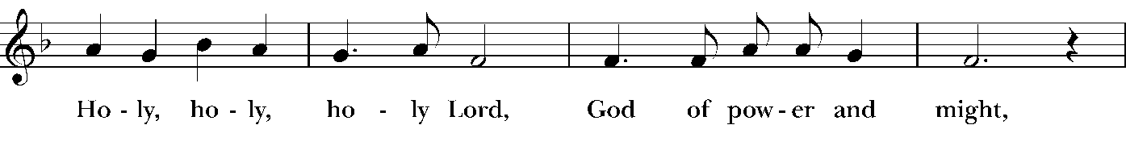
Sanctus S 125 Hymnal 1982
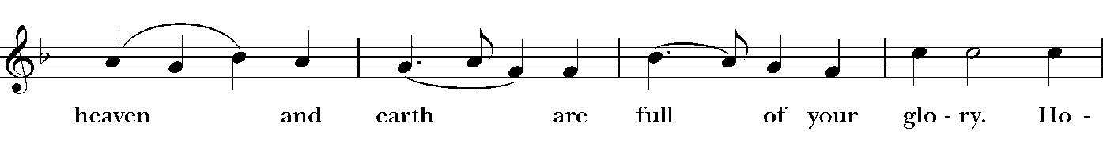

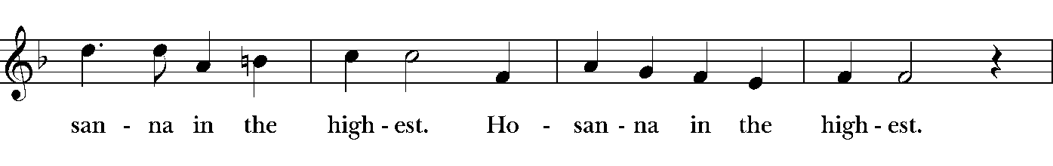

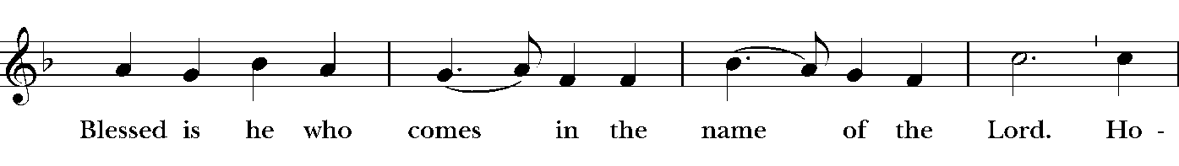

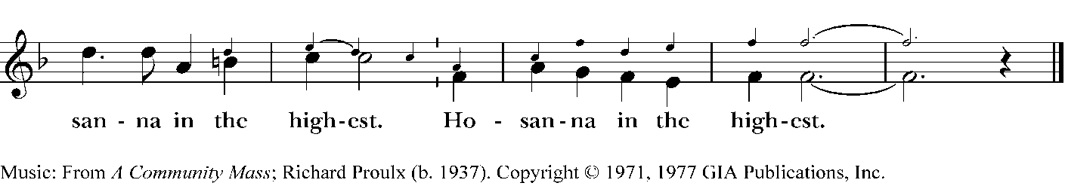

Holy and gracious Father: In your infinite love you made us for yourself; and, when we had fallen into sin and become subject to evil and death, you, in your mercy, sent Jesus Christ, your only and eternal Son, to share our human nature, to live and die as one of us, to reconcile us to you, the
God and Father of all.

He stretched out his arms upon the cross, and offered himself, in obedience to your will, a perfect sacrifice for the whole world. At the following words concerning the bread, the Celebrant is to hold it,
or lay a hand upon it; and at the words concerning the cup, to hold or place a hand upon the cup and any other vessel containing wine to be consecrated.
On the night he was handed over to suffering and death, our Lord Jesus Christ took bread; and when he had given thanks to you, he broke it, and gave it to his disciples, and said, “Take, eat: This is my Body, which is given for you. Do this for the remembrance of me.”

After supper he took the cup of wine; and when he had given thanks, he gave it to them, and said, “Drink this, all of you: This is my Blood of the new Covenant, which is shed for you and for many for the forgiveness of sins. Whenever you drink it, do this for the remembrance of me.”

Therefore we proclaim the mystery of faith:

Celebrant and People
Christ has died.
Christ is risen.
Christ will come again.

We celebrate the memorial of our redemption, O Father, in this sacrifice of praise and thanksgiving. Recalling his death, resurrection, and ascension, we offer you these gifts.

Sanctify them by your Holy Spirit to be for your people the Body and Blood of your Son, the holy food and drink of new and unending life in him. Sanctify us also that we may faithfully receive this holy Sacrament, and serve you in unity, constancy, and peace; and at the last day bring us with all your saints into the joy of your eternal kingdom.

All this we ask through your Son Jesus Christ. By him, and with him, and in him, in the unity of the Holy Spirit all honor and glory is yours, Almighty Father, now and for ever. Amen.

And now, as our Savior Christ has taught us, we are bold to say,

Our Father, who art in heaven, hallowed be thy Name, thy kingdom come, thy will be done, on earth as it is in heaven. Give us this day our daily bread. And forgive us our trespasses, who trespass against us. And lead us not into temptation, but deliver us from evil. For thine is the kingdom, and the power, and the glory, for ever and ever. Amen.

The Breaking of the Bread
The Celebrant breaks the consecrated Bread. A period of silence is kept.
[Alleluia.] Christ our Passover is sacrificed for us;
Therefore let us keep the feast. [Alleluia.]

The Gifts of God for the People of God. Take them in remembrance that Christ died for you, and feed on him in your hearts by faith, with thanksgiving.
Please follow the directions of the ushers

The Bread and the Cup are given to the communicants with these words:

The Body of Christ, the bread of heaven. [Amen.]
The Blood of Christ, the cup of salvation. [Amen.]

Communion Hymn Come, Risen Lord, and Deign To Be Our Guest #306 Hymnal 1982

Post-Communion Prayer
Let us pray.

Christ, you are risen with the sun; you are light in our darkness, warmth in our cold. You are peace and hope and joy, for you went willingly to death. You turned defeat and failure to victory for all. You live eternally, and with you live the millions, living and dead, who trust in you.

Blessing
May God, who through the resurrection of our Lord Jesus Christ has given us the victory, give you joy and peace in your faith and may the blessing of God almighty, Father, Son and Holy Spirit, be with you and remain with you forever. Amen.
Announcements

(continued)

Recessional Hymn To God Be The Glory #108 Voices Found

1 To God be the glory,
great things he hath done!
So loved he the world
that he gave us his son,
who yielded his life,
an atonement for sin,
and opened the life-gate,
that all may go in.

Refrain
Praise the Lord! Praise the Lord!
Let the earth hear his voice!
Praise the Lord! Praise the Lord!
Let the people rejoice!
O come to the Father,
through Jesus the son,
and give him the glory!
Great things he has done!

2 O perfect redemption,
the purchase of blood!
To every believer
the promise of God!
The vilest offender
who truly believes,
that moment from Jesus
forgiveness receives.
Refrain

Celebrant Alleluia, alleluia. Go in peace to love and serve the Lord.
People Thanks be to God. Alleluia, alleluia.

Postlude Voluntary on 'Truro' (Christ is Alive) arr. Hal Hopson

Those serving in today’s service

James Creutz, reader; Elaine Mason, greeter; Meg Pappas, usher
Bob Lawton, LEM; Karen Butler and Jean Bertrand, coffee hosts
Cathy Walsman, flower delivery

On Sunday, April 21
Bill Lutz, reader; Jean Bertrand, greeter, usher
Kam Anderson, LEM; Betty Ann Waldo, coffee host
Kam Anderson, flower delivery

News and Noteworthy

Upcoming Events

April 17, 9:30am Pastoral Care Committee meeting
April 21 Bishop Gates visit
April 21, 3:00pm Matt York concert

Ongoing

Tuesdays, 12:00pm Book Group
Wednesdays, 5:00pm Contemplative Service with Taizé music
Thursdays, 5:00pm Choir rehearsal

Important Information – Bishop Visit
Next week, on Sunday, April 21, our Bishop, the Right Reverend Alan Gates, will be making his official visitation to our parish. Bishop Gates will be retiring this year, so this will be his last visit with us. I encourage everyone to join us for this wonderful opportunity to be with our Bishop. During his visit he will be receiving one person. If there is anyone else who may wish to be received or individually reaffirm their baptismal vows, this is a wonderful opportunity to do so. Please let Mother Donna know no later than this Tuesday so we can have your name for the Bishop.

This Sunday we will have another session of “All You Wanted to Know about the Episcopal Church”. We will discuss “What is a bishop, why are they important, and do we need them anyway?” Please join in to learn all you ever wanted to know about bishops.

Bishop Election -- The Transition Committee of the Diocese of Massachusetts has scheduled a series of open meetings around the diocese, giving people an opportunity to meet and learn more about the nominees for election as the diocese's 17th bishop diocesan. The one on the Cape is:
Wednesday, May 8, 10-11:30 a.m. at St. Mary's Church, 3055 Main Street, Barnstable.

Please consider posting page 12 of this bulletin somewhere around town.
Christ Church Episcopal
invites the community to a
FREE CONCERT FEATURING
Matt York
Matt will perform songs, stories, and gospel-inspired music of Johnny Cash, Willie Nelson, Waylon Jennings, Kris Kristofferson (The Highwaymen) and more.
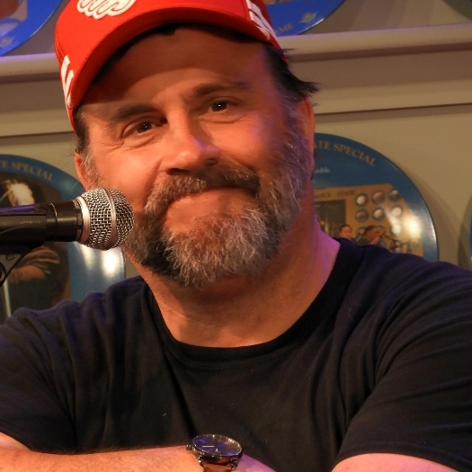

Sunday, April 21, 3:00pm
671 Route 28, Harwich Port
Donations appreciated

Acts 3:12-19
1 John 3:1-7
Luke 24:36b-48

